Course Five

Regression Analysis: Simplifying Complex Data Relationships
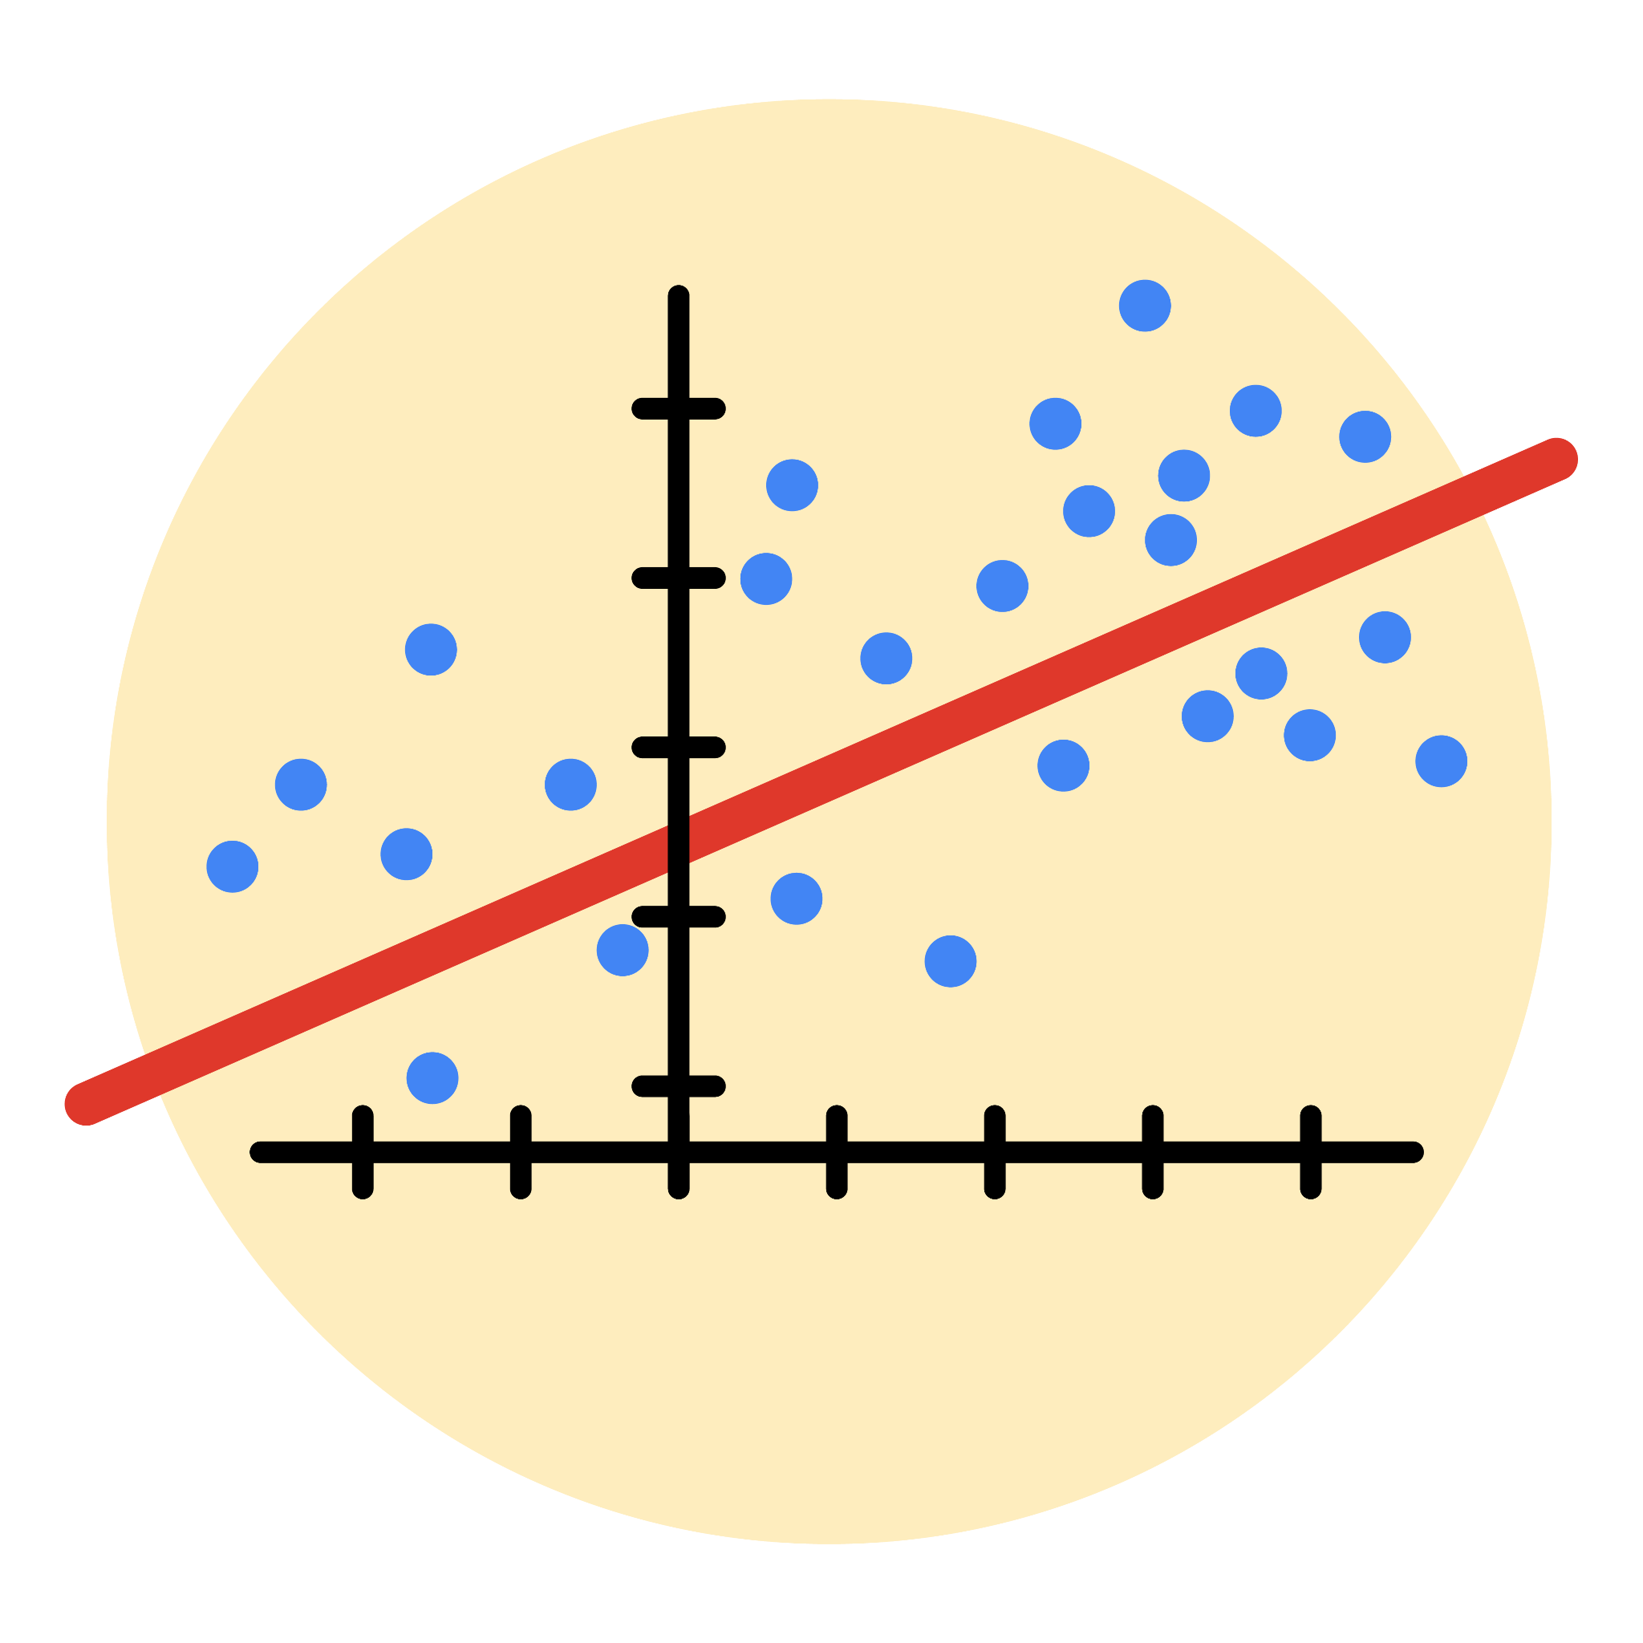

Instructions
Use this PACE strategy document to record decisions and reflections as you work through this end-of-course project. As a reminder, this document is a resource that you can reference in the future, and a guide to help you consider responses and reflections posed at various points throughout projects.

Course Project Recap
Regardless of which track you have chosen to complete, your goals for this project are:
- Complete the questions in the Course 5 PACE strategy document
- Answer the questions in the Jupyter notebook project file
- Build a multiple linear regression model
- Evaluate the model
- Create an executive summary for team members

Relevant Interview Questions
Completing the end-of-course project will empower you to respond to the following interview topics:
- Describe the steps you would take to run a regression-based analysis
- List and describe the critical assumptions of linear regression
- What is the primary difference between R² and adjusted R²?
- How do you interpret a Q-Q plot in a linear regression model?
- What is the bias-variance tradeoff? How does it relate to building a multiple linear regression model? Consider variable selection and adjusted R².

Reference Guide
This project has seven tasks; the visual below identifies how the stages of PACE are incorporated across those tasks.
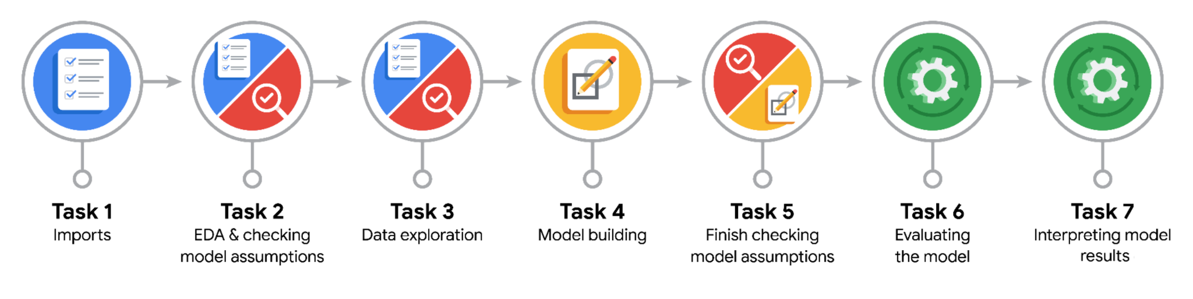

Data Project Questions & Considerations
PACE: Plan Stage
- Who are your external stakeholders for this project?

Waze Management

- What are you trying to solve or accomplish?
We are trying to build a binomial logistic regression model to predict user churn for Waze. This involves identifying patterns in user behavior and characteristics that indicate a higher probability of churning, ultimately allowing Waze to potentially intervene and retain those users.

- What are your initial observations when you explore the data?

Missing Data: The target variable (label) has missing values.
Potential Outliers: Several numerical columns show signs of having extreme values.
Imbalanced Target: The number of retained users is significantly higher than the number of churned users.
Correlated Features: Some predictor variables are highly correlated with each other.

- What resources do you find yourself using as you complete this stage?
Python Libraries: Specifically, libraries like pandas for data manipulation and cleaning, numpy for numerical operations, matplotlib and seaborn for data visualization, and sklearn (scikit-learn) for machine learning tasks, including model building, splitting data, and evaluating the model.
Previous Notebooks/Lessons: I draw upon the concepts and techniques learned in previous stages of this project and in the course materials regarding EDA, feature engineering, and the assumptions of logistic regression.

PACE: Analyze Stage
- What are some purposes of EDA before constructing a multiple linear regression model?
Data Quality Check: Identify and handle missing values and outliers.
Variable Understanding: Explore distributions and characteristics of individual variables.
Relationship Analysis: Examine relationships between variables, especially between predictors and the target, and among predictors to identify potential multicollinearity.
Feature Selection and Engineering: Inform the selection of relevant features and inspire the creation of new ones.
Assumption Assessment: Gain initial insights into whether modeling assumptions are likely to be met.

Data Bias: Recognizing and mitigating biases in the dataset that could lead to unfair model predictions.
Fairness: Ensuring the model's predictions are fair and do not discriminate against specific user groups.
Transparency: Striving for model explainability to understand the reasons behind predictions and build trust.
Privacy: Protecting user data and adhering to privacy regulations.
Consequence Analysis: Considering the potential positive and negative impacts of the model's predictions on users and the business

PACE: Construct Stage
- Do you notice anything odd?
Division by Zero: The unexpected infinite values in km_per_driving_day were caused by dividing by zero when a user had no driving days.
Uneven Churn Distribution: The dataset has a significant imbalance, with many more users who were retained than those who churned.
Redundant Information: Some predictor variables are highly correlated with each other, meaning they provide similar information.
Extreme Values: Several numerica

- Can you improve it? Is there anything you would change about the model?
Address Class Imbalance: Implement techniques like oversampling, undersampling, or using weighted models to improve the identification of churned users (recall).
Explore Other Models: Try alternative classification algorithms like Random Forests or Gradient Boosting Machines, which may handle the data characteristics better.
Refine Feature Engineering: Create more sophisticated features or handle outliers differently to better capture churn patterns.
Tune Hyperparameters: Optimize model settings to improve performance based on relevant evaluation metrics.
Incorporate Domain Knowledge: Seek input from Waze experts to identify missing factors and potential new data sources.
Analyze Model Errors: Examine incorrect predictions (false negatives/positives) to understand model weaknesses and guide further improvements.

- What resources do you find yourself using as you complete this stage?
Python Libraries:
sklearn: This is the core library for machine learning, used for splitting data (train_test_split), building the logistic regression model (LogisticRegression), and evaluating it with various metrics (confusion_matrix, ConfusionMatrixDisplay, classification_report, accuracy_score, precision_score, recall_score, f1_score).
pandas and numpy: Used for data manipulation, creating dataframes, and numerical operations, which are essential for preparing the data and working with the model outputs (e.g., creating the logit_data dataframe).
matplotlib and seaborn: Used for visualizing the results, specifically for plotting the correlation heatmap and the confusion matrix display.

PACE: Execute Stage
- What key insights emerged from your model(s)?
Activity is a Key Driver: The activity_days variable is a significant predictor of churn, indicating that users who are less active are more likely to churn.
Model Struggles with Identifying Churners: While the model has decent overall accuracy and good precision, its low recall means it is not effective at identifying a large portion of users who will actually churn.
Professional Drivers Less Likely to Churn: The engineered professional_driver feature shows that users identified as professional drivers have a significantly lower churn rate than non-professional drivers.

- What business recommendations do you propose based on the models built?
Target Users with Low Activity: Focus retention efforts on users exhibiting low activity_days, as this is a key indicator of potential churn according to the model.
Leverage High-Confidence Predictions: Use the model's predictions where it has high confidence (due to good precision) to prioritize users for targeted interventions, even if the model misses many churners overall.
Explore Professional Driver Program: Investigate the reasons behind the lower churn rate among professional drivers and consider developing programs or features tailored to this segment to further enhance their retention and potentially encourage similar behavior in other users.
Investigate Root Causes of Low Activity: Conduct further research to understand why some users have low activity levels and address those underlying issues through product improvements or communication strategies.

- To interpret model results, why is it important to interpret the beta coefficients?
Understanding Feature Impact: The coefficients indicate the direction (positive or negative) and magnitude of the relationship between each predictor variable and the log odds of the target variable (in this case, churning). A positive coefficient means an increase in the predictor is associated with an increase in the log odds of churning, while a negative coefficient means the opposite.
Quantifying Relationships: The absolute value of a coefficient (when variables are on comparable scales or after scaling) can give an indication of the relative importance of each predictor in influencing the likelihood of the outcome. A larger absolute value generally suggests a stronger impact.
Business Insights: Translating the coefficients into understandable terms (even if not directly as probability changes due to the log-odds transformation) provides actionable insights for the business. For example, understanding that lower activity days increase the likelihood of churn allows Waze to focus on engagement strategies.
Model Explainability: Coefficients make logistic regression a relatively interpretable model, allowing stakeholders to understand which factors are driving the predictions, fostering trust and facilitating informed decision-making.
Hypothesis Testing: While not explicitly done in this notebook, the significance of coefficients can be tested to determine if the relationship between a predictor and the target is statistically significant.

- What potential recommendations would you make?
Prioritize Retention Efforts on Inactive Users: Focus Waze's retention campaigns on users with low activity levels, as the model identified activity_days as a significant predictor of churn.
Leverage High-Precision Predictions for Targeted Outreach: Use the model's predictions where it is most confident to identify a subset of likely churners for proactive intervention, acknowledging that the model won't catch everyone.
Deepen Understanding of Professional Drivers: Investigate the factors that contribute to the lower churn rate among professional drivers to identify best practices or features that could be extended to a wider user base.
Explore Strategies to Boost User Activity: Develop initiatives or product features designed to increase user engagement and activity, as inactivity is strongly linked to churn.
Enhance the Churn Prediction Model: Continue to improve the model by addressing the class imbalance, exploring alternative algorithms, and incorporating additional relevant data to increase its ability to identify churners (improve recall).

- Do you think your model could be improved? Why or why not? How?
Can it be improved? Why?

Yes, significantly.
Low Recall: The main reason is the model's poor ability to identify actual churners (low recall). It misses most of them.
Class Imbalance: The imbalanced dataset (more retained than churned users) likely contributes to the low recall.
How to improve it:

Address Class Imbalance: Use techniques like oversampling (SMOTE) or undersampling the data.
Explore Other Models: Try different machine learning algorithms (e.g., Random Forests, Gradient Boosting) that might perform better.
Refine Feature Engineering: Create new, more informative features or handle existing ones differently.
Tune Model Settings: Optimize the model's hyperparameters to improve performance, particularly recall.

- What business/organizational recommendations would you propose based on the models built?
Prioritize Low-Activity Users: Waze should focus retention efforts on users with few activity_days, as they are the most likely to churn.
Targeted Outreach with Confidence: Use the model's high-precision predictions (where it's confident a user will churn) for specific interventions, like personalized offers or communications.
Analyze Professional Driver Success: Study the habits and characteristics of professional drivers, who have lower churn, to potentially apply insights to other user segments.
Initiatives to Increase Engagement: Develop programs or features to encourage users to be more active in the app, addressing the link between inactivity and churn.
Invest in Model Enhancement: Continue to improve the churn prediction model by addressing data imbalance and exploring other techniques to increase its effectiveness in identifying churners.

- Given what you know about the data and the models you were using, what other questions could you address for the team?

What are the specific characteristics of users who are falsely predicted (false positives and false negatives)? Analyzing the attributes of users the model gets wrong can provide insights into its limitations and guide further improvements.
Are there different segments of users with distinct churn patterns? Clustering analysis could reveal different types of users (e.g., professional drivers vs. occasional users) who might require different retention strategies.
What is the predicted churn probability for individual users? Instead of just a binary churn/retain prediction, providing a probability score allows the business to prioritize intervention based on the level of risk.
How does churn vary over time or by location? Analyzing temporal and geographical patterns in churn could inform localized or seasonal retention efforts.
What is the potential impact of different interventions on reducing churn? While the current model predicts churn, future analysis could explore the potential effectiveness of different retention strategies on different user segments.
What other data could be valuable for improving churn prediction? Identifying additional data sources, such as user feedback, in-app event tracking (beyond drives and sessions), or customer support interactions, could enhance the model.

- Do you have any ethical considerations at this stage?

Fairness in Predictions: Ensuring the model doesn't unfairly discriminate against certain user groups based on protected attributes (even if not directly used as features).
Bias Amplification: Recognizing that biases present in the data can be amplified by the model, potentially leading to biased outcomes in retention efforts.
Transparency: While logistic regression is relatively interpretable, the complexities of feature engineering and potential future model choices might require efforts to explain why the model is making specific predictions.
Consequences of Errors: Understanding the business and user impact of false positives (incorrectly targeting retained users) and false negatives (missing actual churners).
Data Privacy and Security: Maintaining the privacy and security of the user data used for model training and evaluation.
Rate this answer

